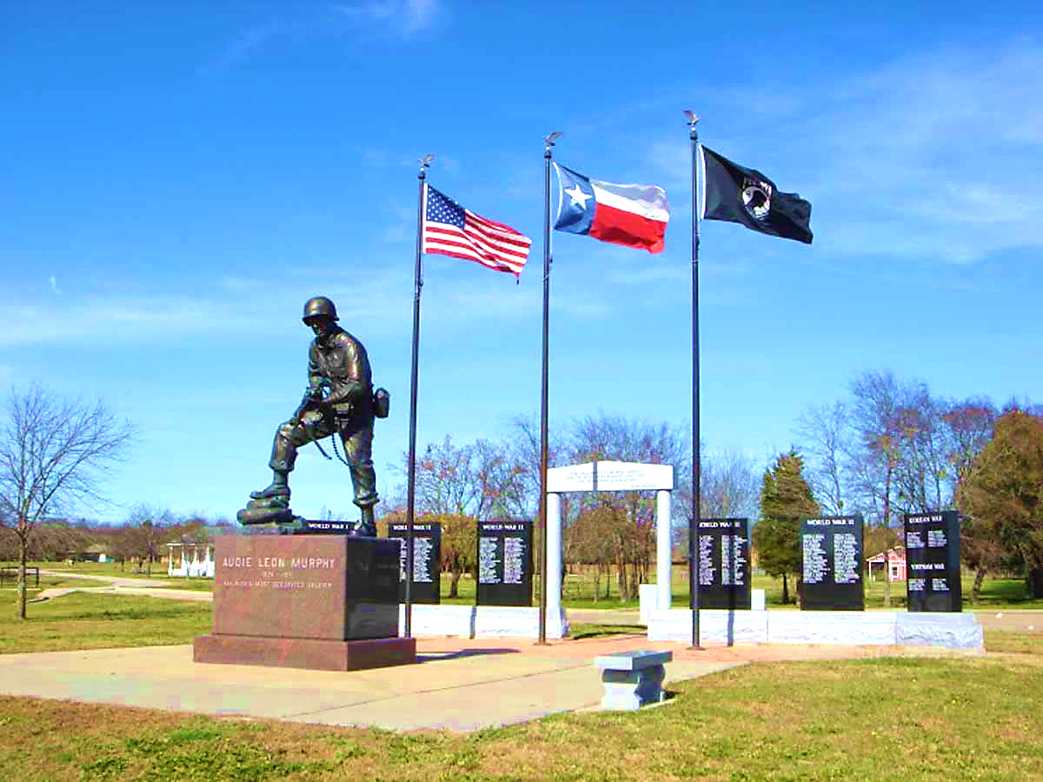
The East Texas Historical Association
Spring Meeting
February 16, 2019
Audie Murphy American Cotton Museum

8:30 A.M. Registration, Coffee, Donuts

8:50 A.M. Welcome & Introductions: Gwen Lawe, ETHA President

9:00 – 9:30 A.M. Kyle Wilkison: “Summer of Love and Horror”

10:00 – 10:45 A.M. Paul Sturdevant: “Black & White with Shades of Gray:
The Greenville Sign”

Anne Haynes, Commentator

11:15 – 11:45 A.M. Scott Sosebee: “How we got here, the Lost Cause and The New
Narrative of placing “Confederate Memorials & Monuments”

12:00 – 1:30 P.M. Lunch

At your leisure please tour the museum exhibits and grounds that include tours of historical monuments.

